Analyzing 2SpOT Data Using IGOR and MATLAB

NOTE: Before beginning this tutorial, you should have already run spike detection on your LabView data, and you should know the directory where these files are saved!

I. Loading Spike Data

Open IGOR Pro. In the Macros menu, select analysis_2SpOT > load_spikes.

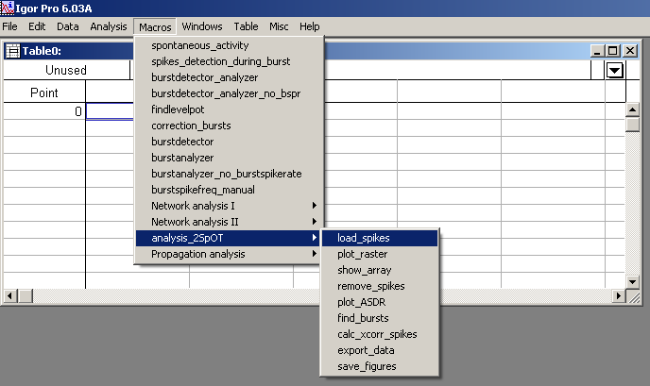

You will see the following dialogue shown below. Adjust the parameters as necessary and click Continue.

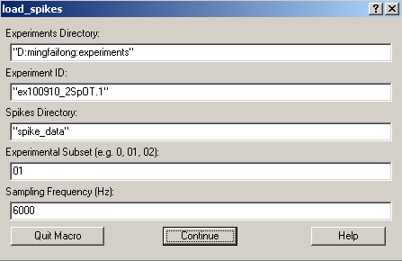

Two tables should appear showing general information about the experiment, as well as the spike detection parameters used. Examples are shown below. (note: the tables may be overlapping, you’ll have to move one to see both).

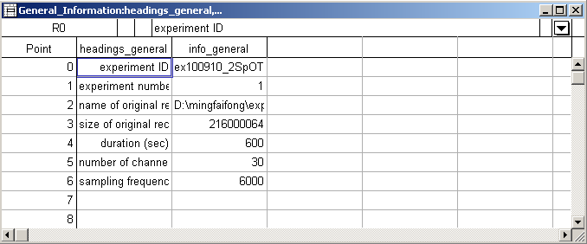

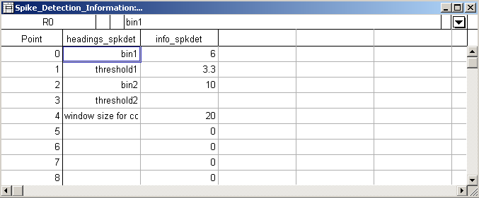

II. Generating Raster Plot

In the Macros menu, select analysis_2SpOT > plot_raster.

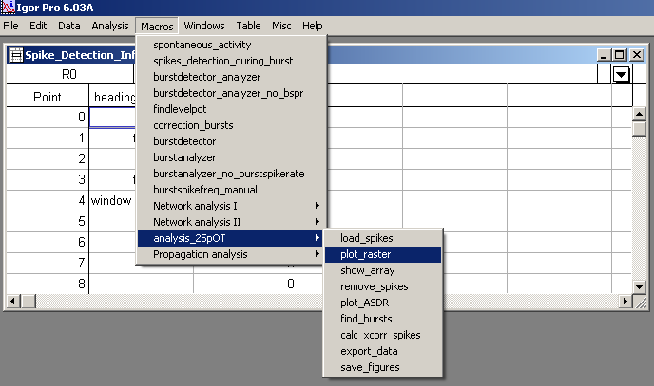

After a short pause, a raster plot of all data should appear.

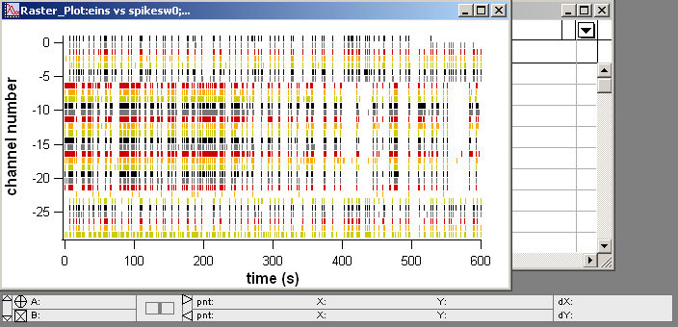

NOTE: Although the data in this example is quite clean, in some cases you may need to remove artifacts or noisy channels. To do this, see the appendices for Removing Spikes and Removing Noisy Channels.
You can zoom in on the data by selecting a small area and then right clicking for zoom options.

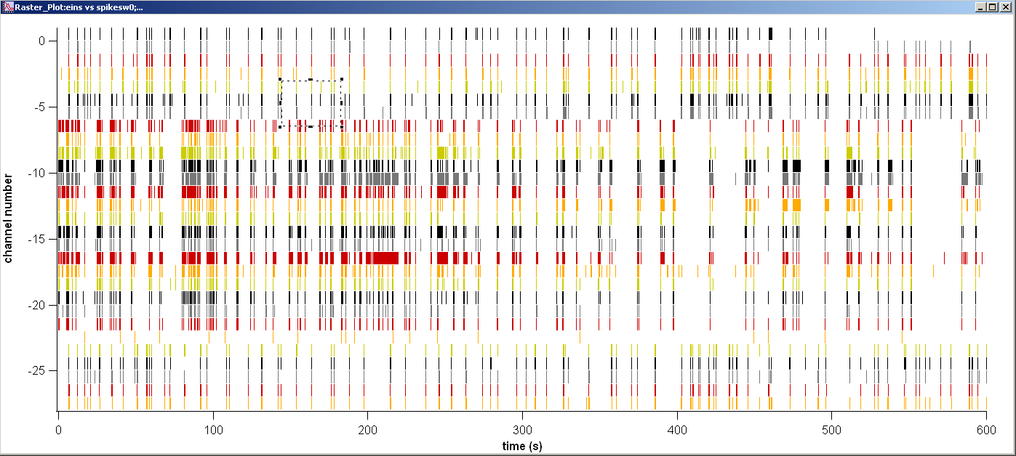

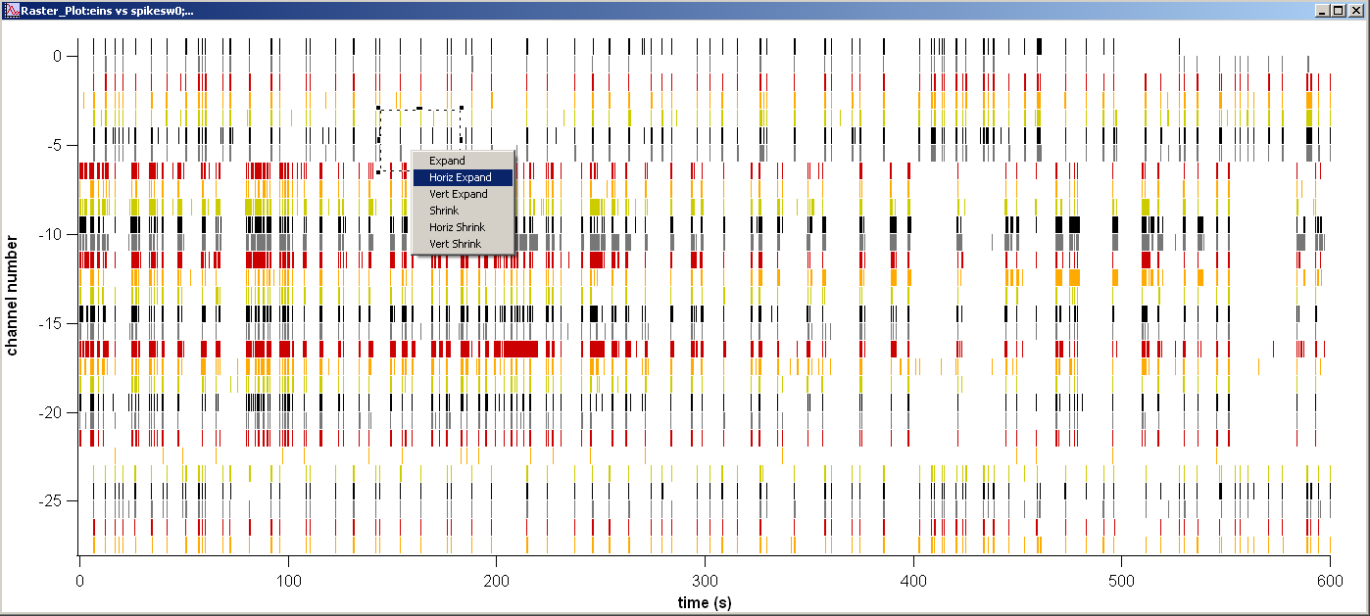

Once zoomed in, you can revert to the original view by right clicking in the white space and selecting Autoscale Axes.

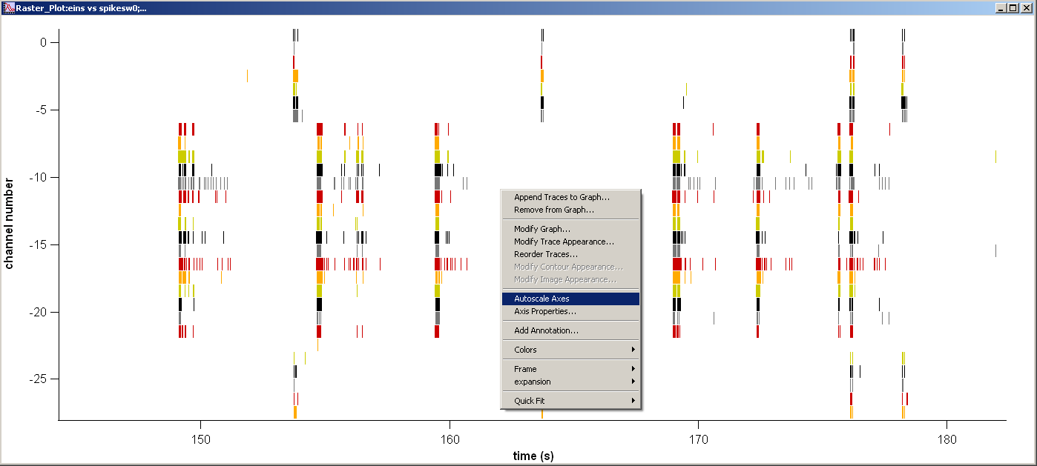
IV. Plotting Network Activity
(note: ASDR stands for array-wide spike detection rate, and is used interchangeably here with the term “network activity”; however, it should be noted that this network activity specifically refers to the rate of extracellular spikes detected).

In the Macros menu, select analysis_2SpOT > show_array.

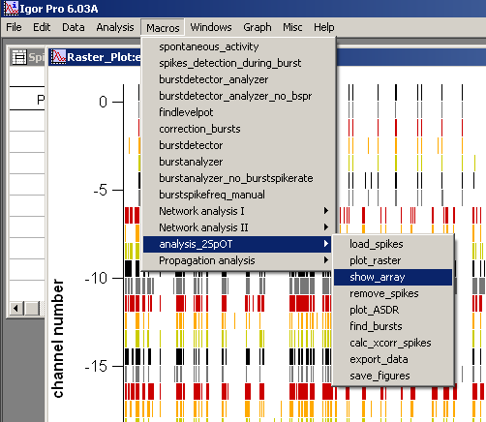

A plot showing the array should appear (as shown below). The “-1” means that this electrode was not used for recording, or indicates the position of the gap between the two sides. In the example below, the left side uses channels 1-6 and 24-29; the right side uses channels 7-23. If you look at the raster plot on the previous page, you can see a clear delineation in synchronous spiking within each of these two groups.

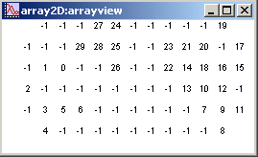

In the Macros menu, select analysis_2SpOT > plot_ASDR.

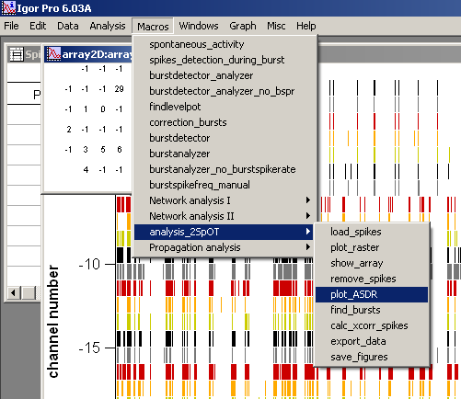

A dialogue box will appear (below). Fill in the data requested, and be sure the enter the correct channel numbers! You can find these by looking at the “show_array” figure (above). Adjust other parameters as desired and click Continue.

before after
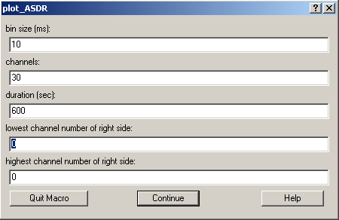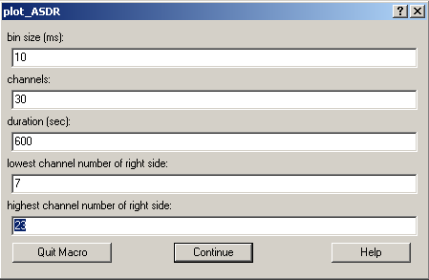

The results will be a plot indicating spike rate on each side. The green lines are used for the left side (netactivity1_w), and the purple lines are used for the right side (netactivity2_w).

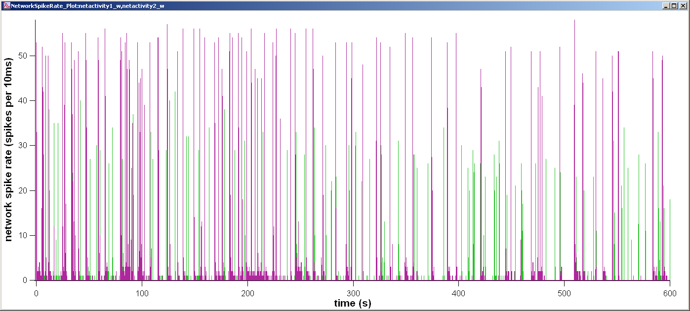

V. Identifying Burst Activity

In the Macros menu, select analysis_2SpOT > find_bursts.

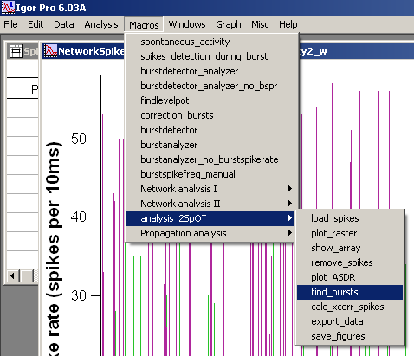

A dialogue box will appear. To look for bursts on the left side, change the “index of netactivitywave” to 1. Looking at the green lines on the network spike rate figure (or ASDR), choose a threshold (I used 20). Any line that rises above this value will be designated as a left side burst. Adjust other parameters as desired and click Continue.

before after
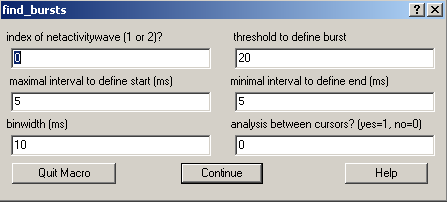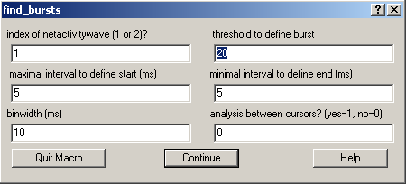

Two things should happen. First, a table with burst start times, stop times, and peak values/times should appear. Secondly, the network spike rate (or ASDR) plot will have red stars that indicate the peak of each burst, and blue lines that appear at the bottom indicating the start/stop of each burst. Examples are shown below.

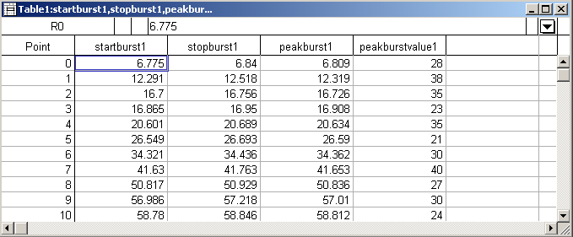

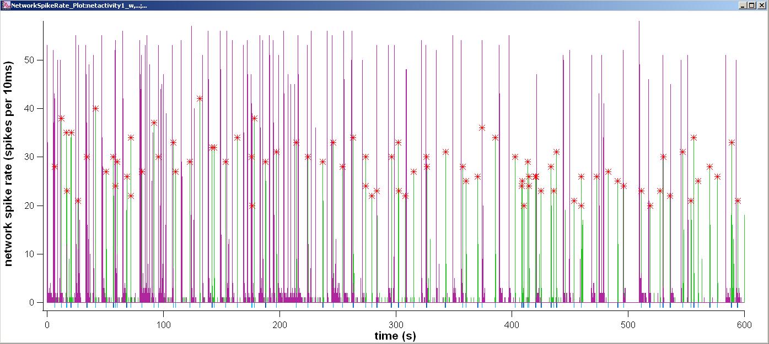

Repeat the same steps to find bursts on the right side of the array. (The netactivitywave index is 2. Since the purple lines are higher in this plot, I used a threshold of 35).

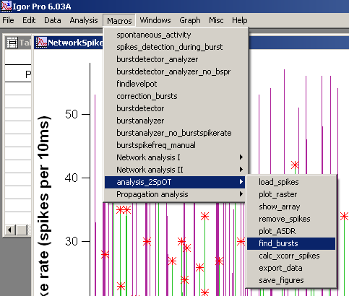

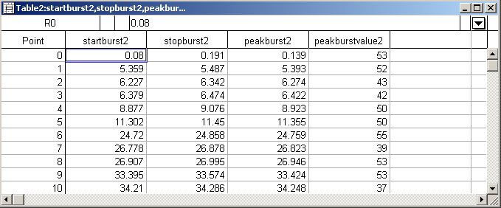

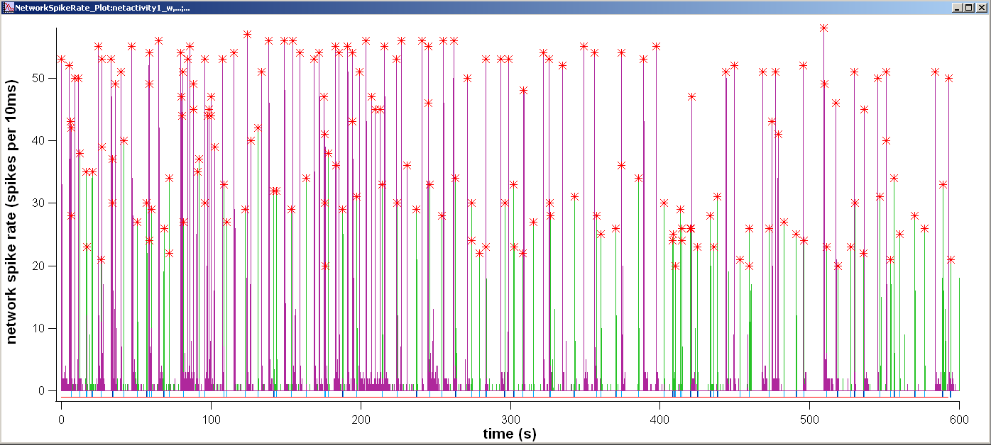

VI. Saving Data

In the Macros menu, select analysis_2SpOT > export_data. This will make data file (in tab-delimited DAT format) in the analysis directory that you can then use for correlation analysis in Matlab.

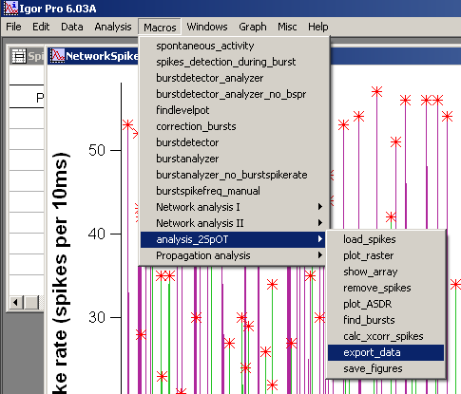

In the Macros menu, select analysis_2SpOT > save_figures. This will make a three picture files (in PNG format) in the analysis directory: the raster plot, array channel mappings, and network activity plot.

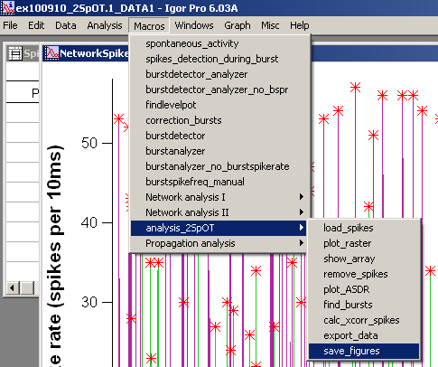
VII. Correlation Analysis

Open MATLAB. In the Command Window, type edit analysis_2SpOT_xcorr.

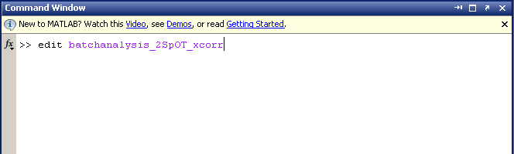

The analysis script will open up.

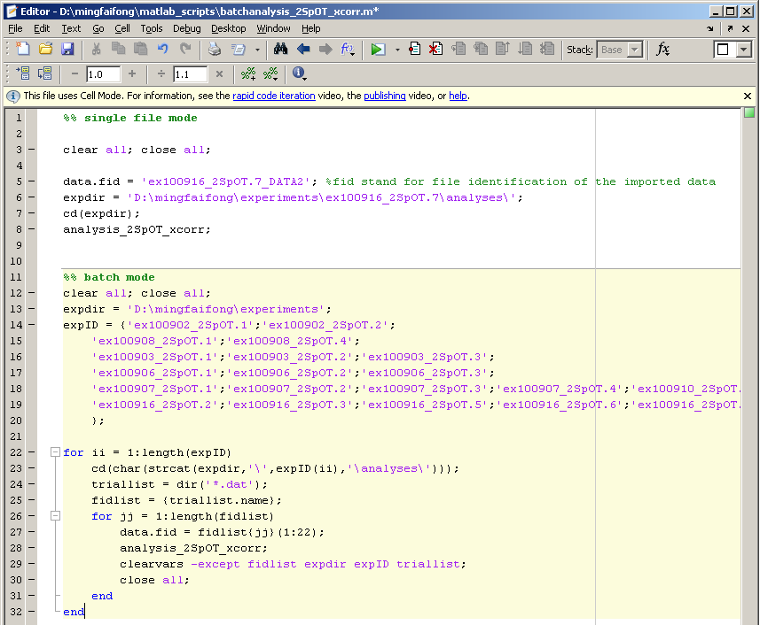

Take note the analyses directory where IGOR saved your files. For example:

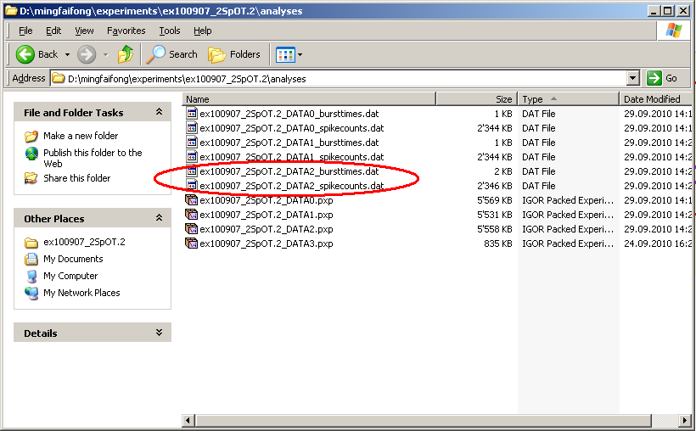

If you have one file to analyze, change “data.fid” to the name of the file to be analyzed. Also change “expdir” to the directory containing the data files saved by IGOR.

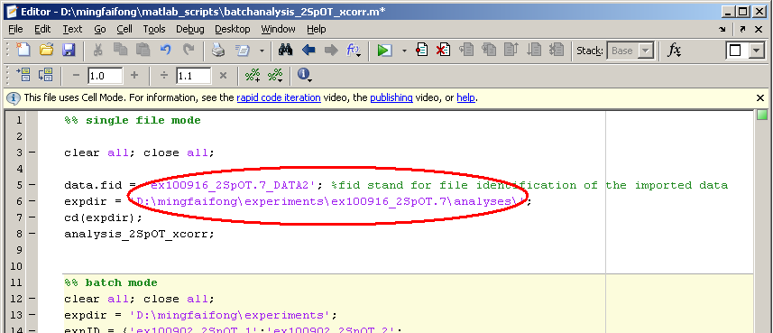

If you have multiple files to analyze, change “expdir” to the directory containing the various experiment files, and then change the “expID” values to reflect the various files you want analyzed. (NOTE: in order to use this, you will need to use the same directory structure I used for saving experiment files. Alternatively, you can edit the script if you feel comfortable with MATLAB).

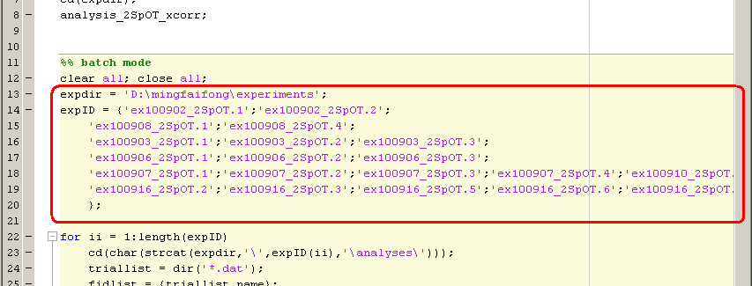

In both cases, the script will save a MATLAB data file (in MAT format) into the analyses directory along with picture files (in PNG format) showing the correlation between spike times and burst times.

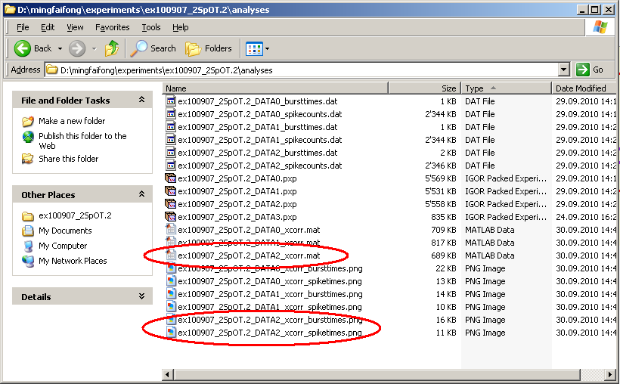

Double click on the MAT file. A dialogue box will open. Click Finish.

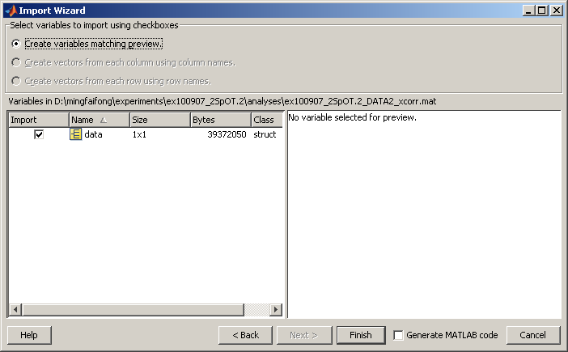

In MATLAB, browse through the data structure by double clicking on the workspace variable.

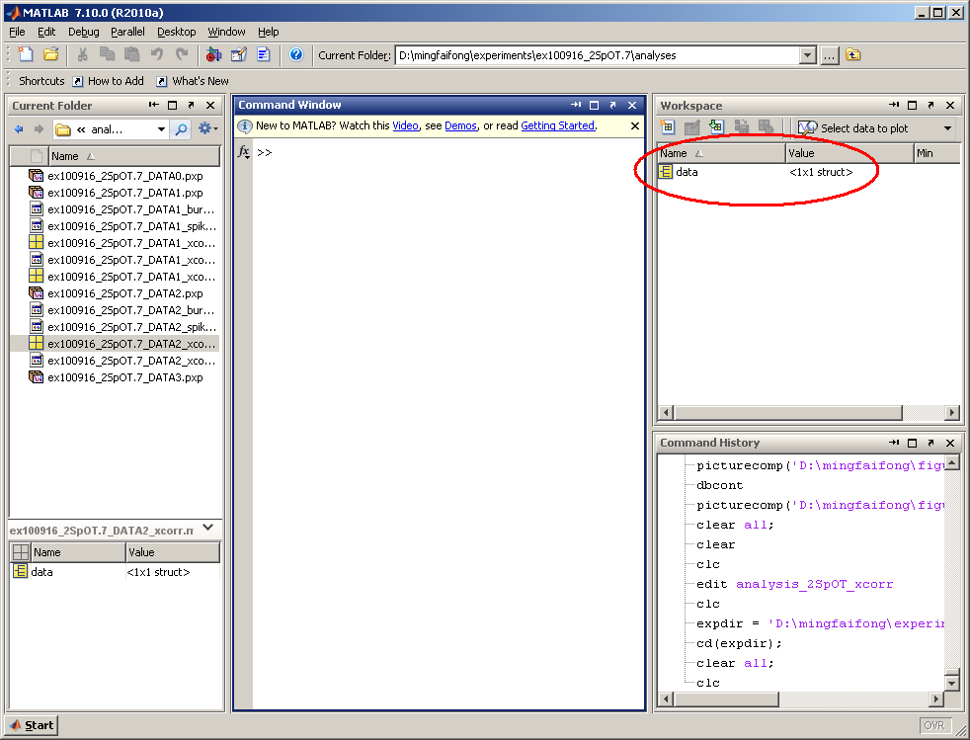

The data structure will open up. Look in the “spikecounts” and “burstcounts” fields to see the cross correlation values, peaks, normalized peaks, and lag at peak for each one. For example, below we can see that the normalized peak value for the cross correlation is 5.2439, and the time this occurs is at 1ms. (NOTE: sometimes you will see NaN, which means Not A Number. This occurs when the correlation is so weak that there is no peak within a reasonable correlation range).

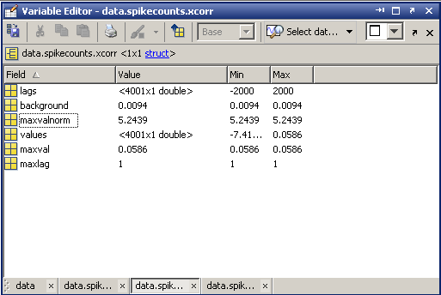

If you open the PNG files, you can see the cross correlation plots generated by MATLAB. As indicated by the data structure, the peak cross correlation for the spike times occurs at 1ms.
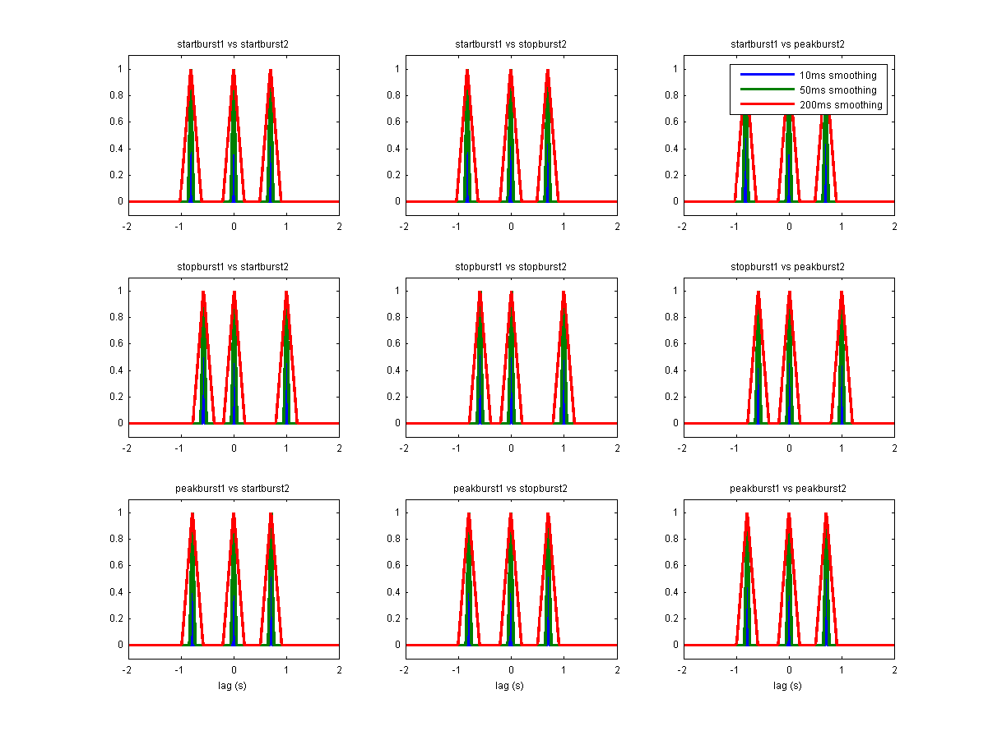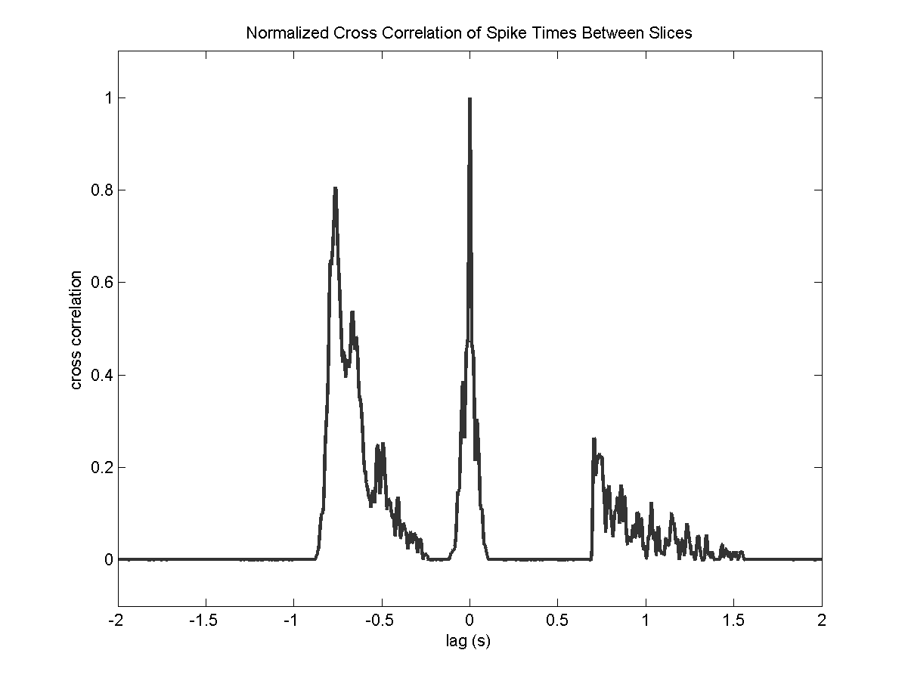
Appendix A: Removing Spikes

In the raster plot below, there are several “spikes” that appear on every channel at the same time, but do not appear to be accompanied by subsequent spikes. To verify that these lines are single “spikes” zoom in temporarily.

(unzoomed)
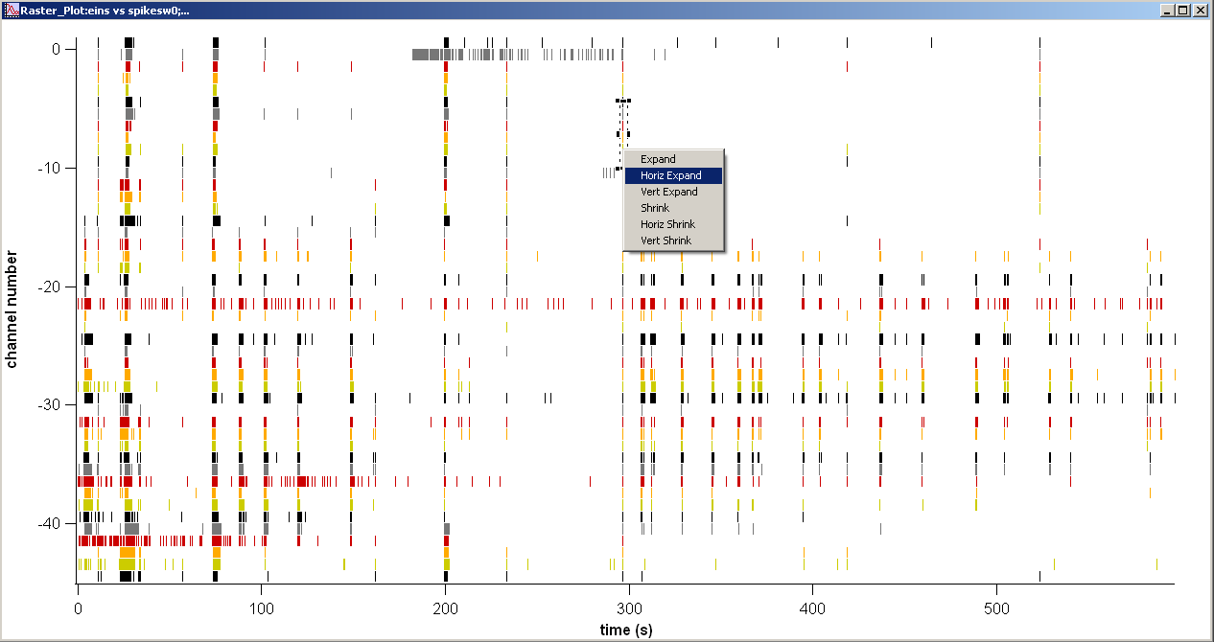

(zoomed)
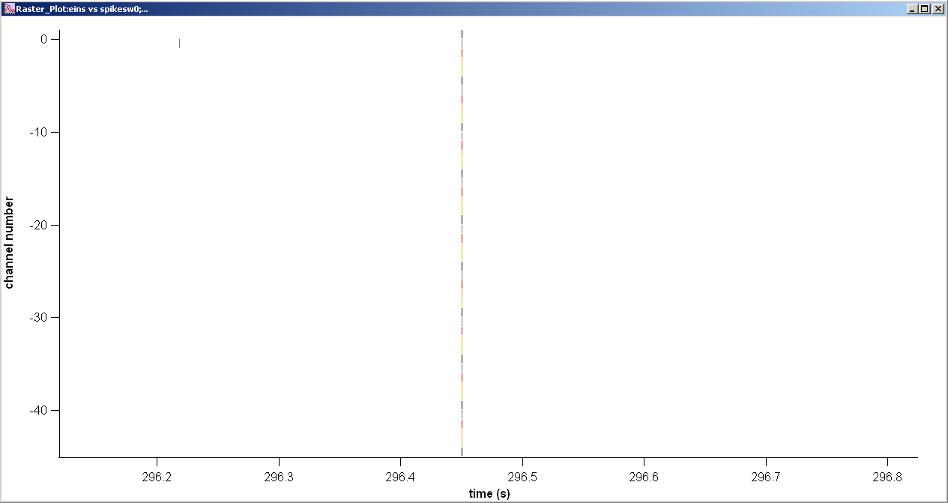

After seeing that this “spike” occurs on every channel simultaneously, without any subsequent spikes, you can be fairly certain that this is an artifact. In the lower left corner of the plot, there is an encircled + symbol next to the letter A. Drag and drop this + sign to the time when the spike occurs.

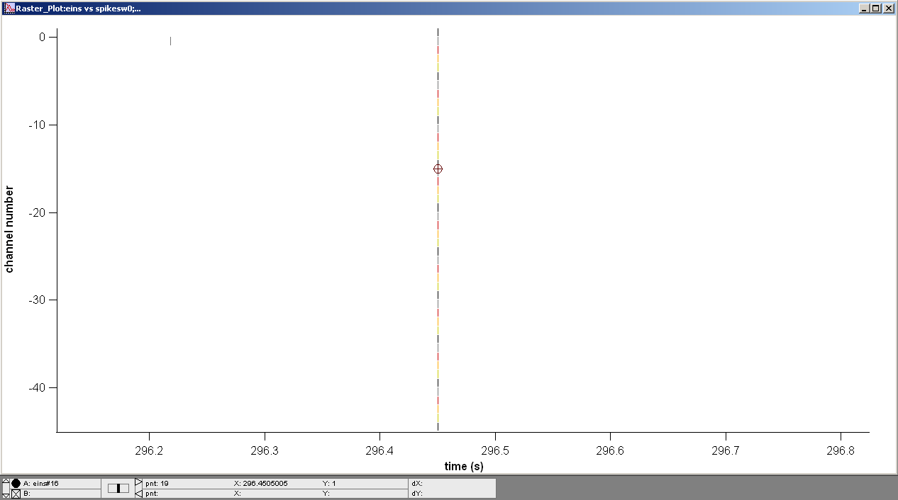

In the Macros menu, select analysis_2SpOT > remove_spikes.

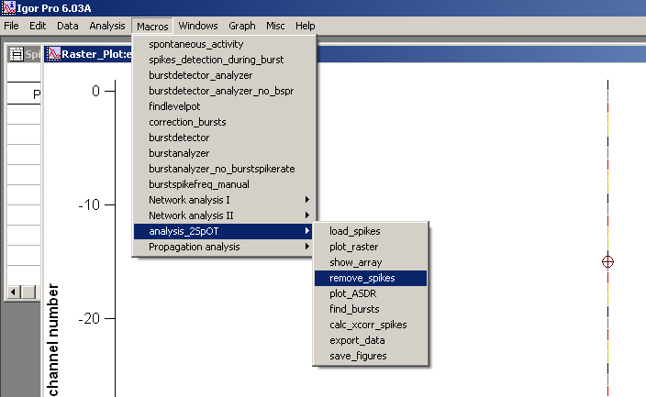

The artifact has now been removed on all channels.

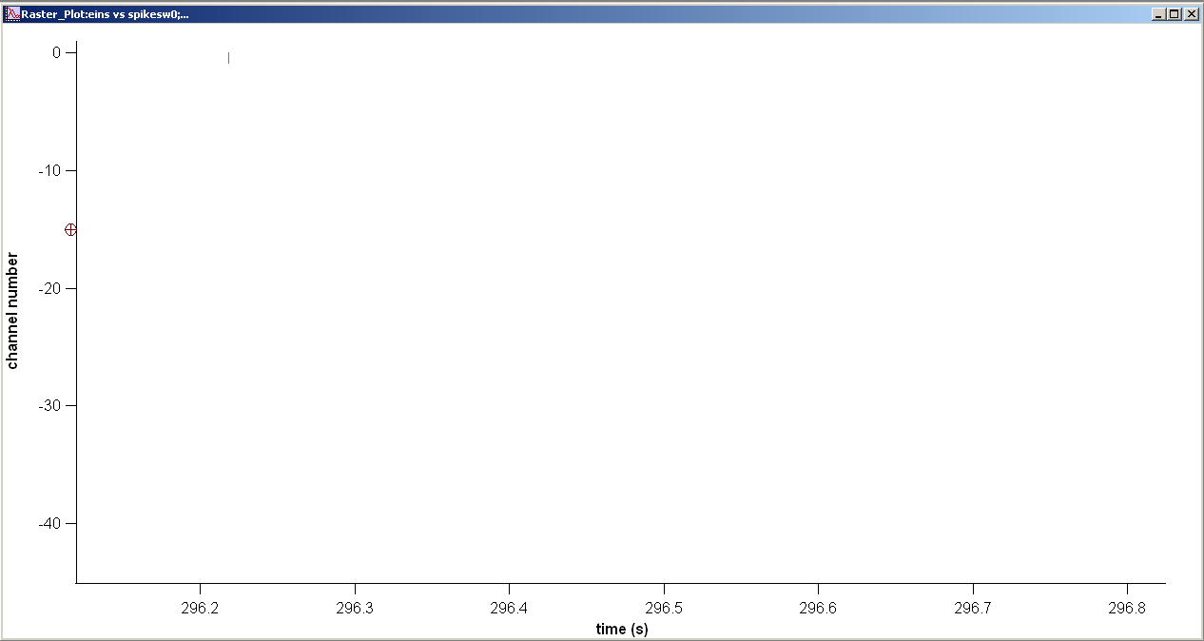

Finally, you can zoom back out and continue to look for artifacts.

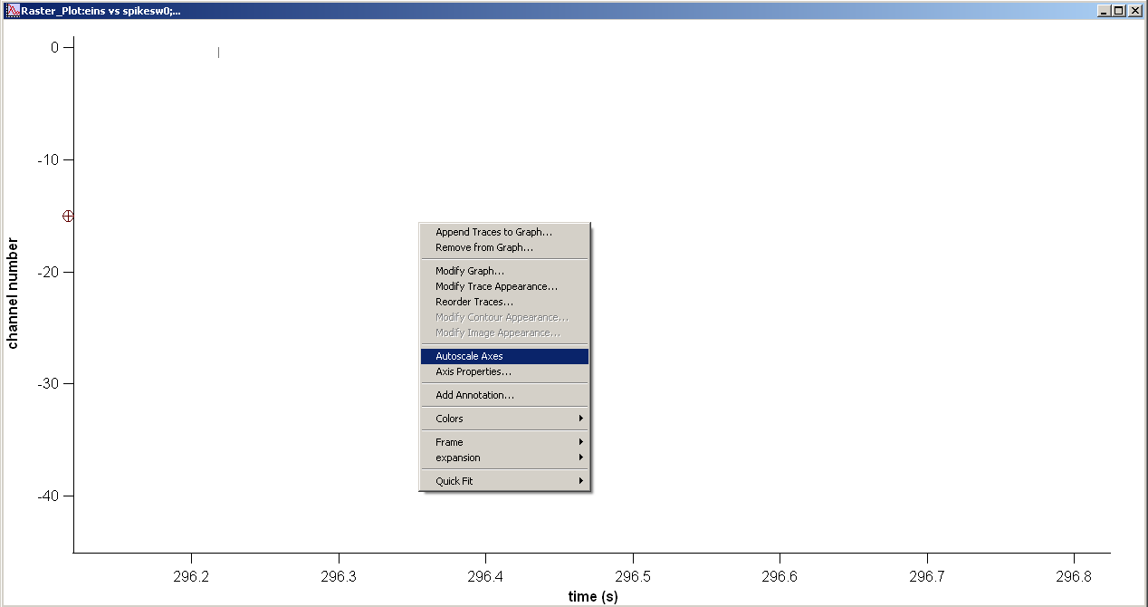

Appendix B: Removing Noisy Channels.

In the raster plot below, two channels, 26 and 27, are clear extremely noisy and should be removed from analysis.

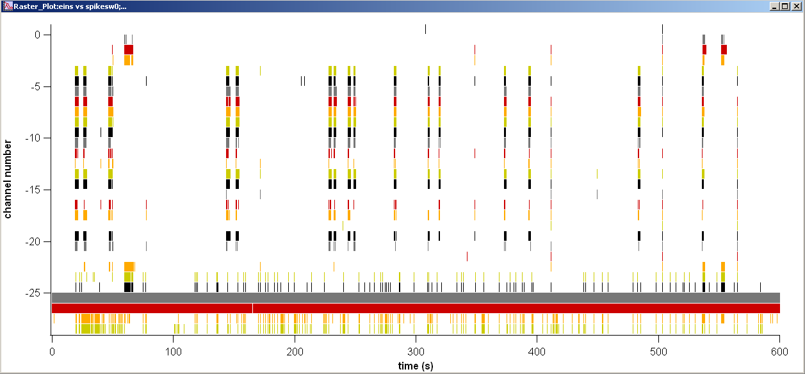

In the Data menu, select Redimension Waves….

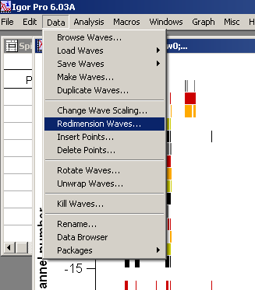

A dialogue box will appear. Click the button “Add All”.

before after
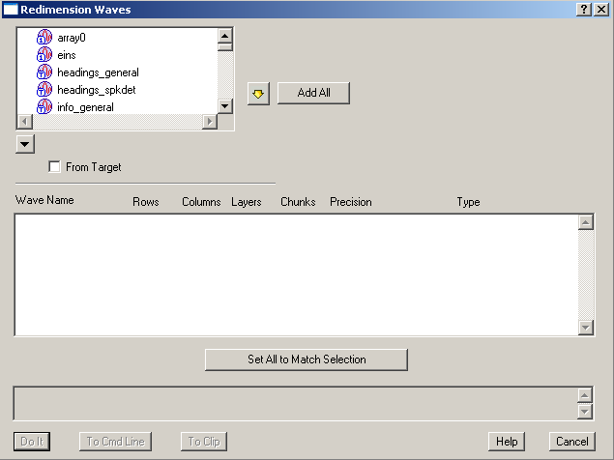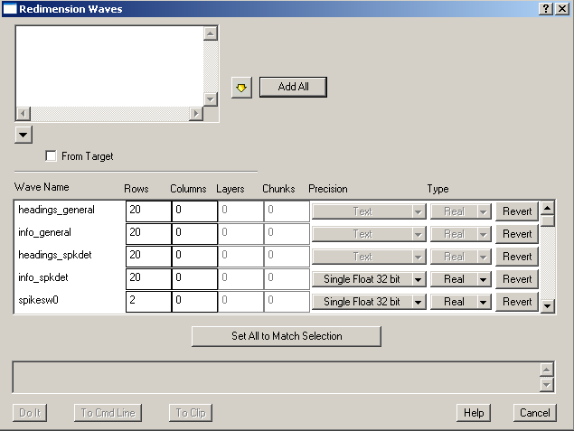

Scrolling down to the “spikesw” with the number of the noisy channel(s). For this example, it is 26 and 27. Change the “rows” parameter to zero. Click Do It.

before after
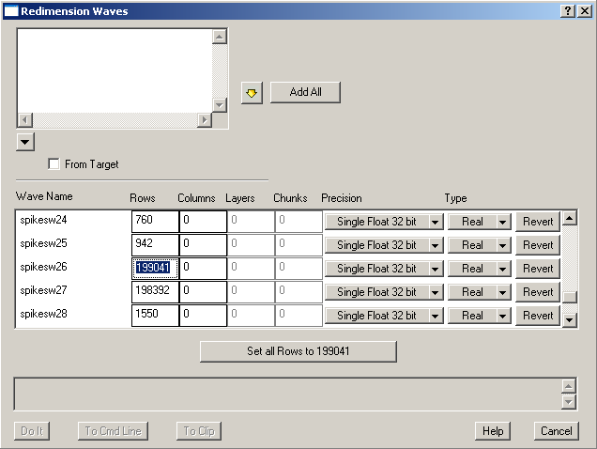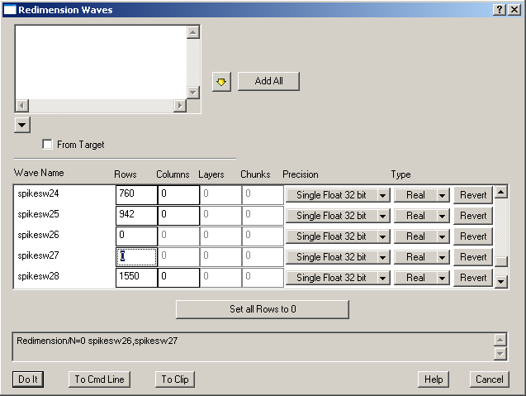

The result is shown below.

